Name_______________________
www.stma-art.com

Sketchbook Assignments: Studio Art

You need to do at least one sketch per week in your sketchbook. The purpose of a sketchbook is to make you look harder at things, use your imagination, as well as explore ideas and techniques that interest, challenge, and stimulate you. You will find that practice does indeed pay off and your confidence in your abilities will increase proportionally to the amount of effort and care you put into your work. Full shading is expected, as are details. Use of colored pencils or other materials like pen and ink or your own favorites are fine! This is your place to experiment and grow! Remember- you're only limited by your own imagination.
You have one week to complete each sketchbook assignment. Sketchbooks are expected to be turned in on time as designated by your instructor. Keep each sketchbook assignment in your sketchbook along with the rubric for assessment. Students who do not turn in their sketchbook at the time of collection will be given a zero for that assignment. Late sketchbook assignments will not be accepted.

Sketchbook assignments are due every _______________
Make sure to # each sketchbook assignment accordingly

- FORM: Draw an object of interest from 3 different views. Work from observation!
- LINE: Perspective: Draw the interior of a room a school hallway complete with floor, ceiling, details, etc.
- SPACE: 2-Point Point Perspective: Draw a cityscape or house complete with streets, details, etc. (a detailed line drawing is acceptable
- VALUE: Draw the contents of your drawer, lunch box, or other container of choice
- SHAPE: Draw or design any kind of vehicle, or draw a pair of shoes
- COLOR: Draw an object cut in half or sliced – real or imaginary
- TEXTURE: Draw a pile of laundry or dishes waiting to get washed, or an object with distinct textures
- CHOICE: Show me your Skills!

Sketchbook assignments are homework, which is worth 20% of your grade.

Sketchbook Assignment:
FORM
Medium: HB/#2 pencil
Draw an object of interest from 3 different views. Work from observation!
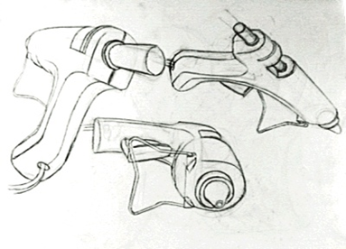

Sketchbook Assignment:
Line
Medium: Pencil or Pen
Draw the interior of a room a school hallway complete with floor, ceiling, details, etc.

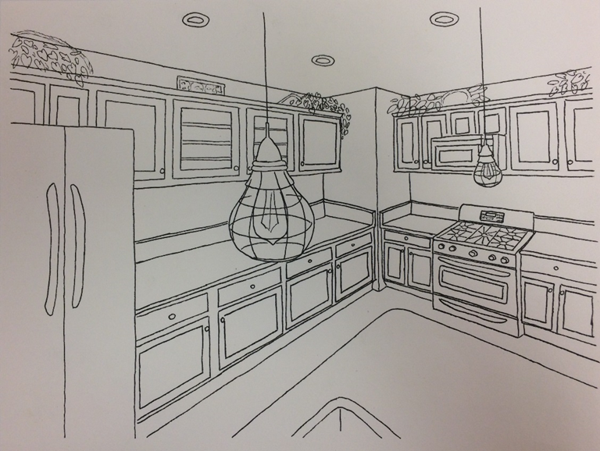
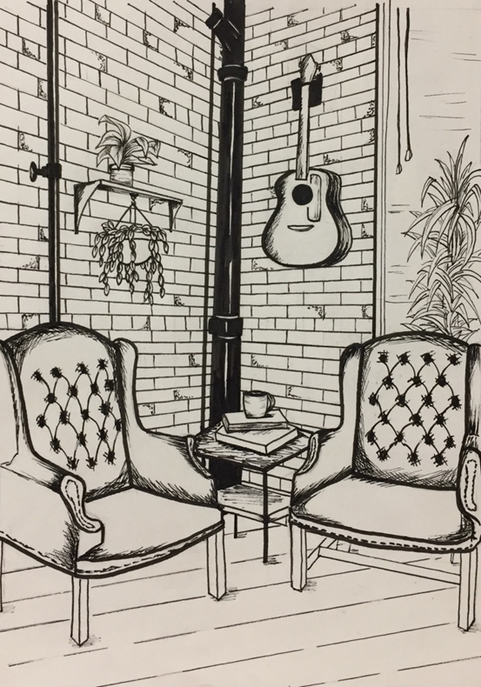

Sketchbook Assignment:
SPACE
Medium: 2H – 2B pencil
Must have shading (value)

2-Point Point Perspective: Draw a cityscape or house complete with streets, details, etc.
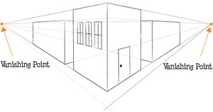
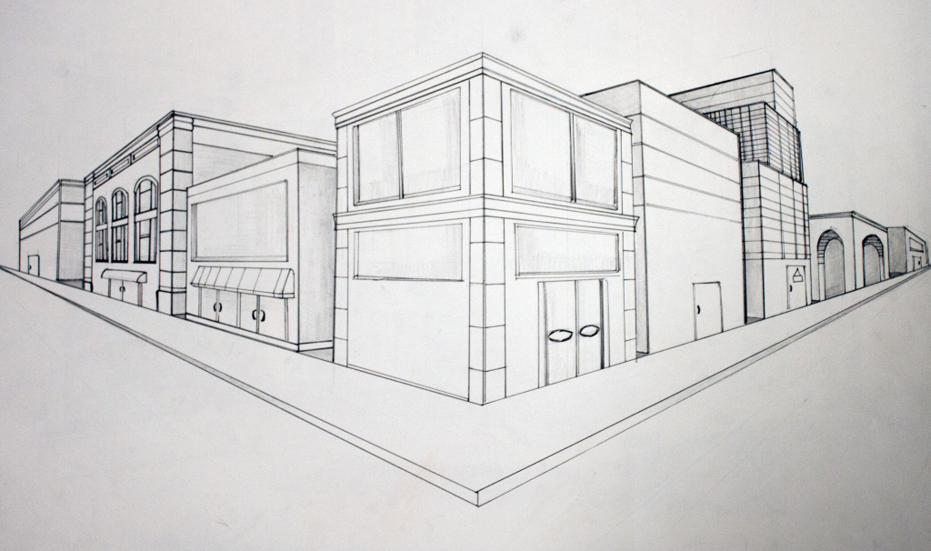

Sketchbook Assignment:
VALUE
Medium: 4H-6B pencils or colored pencil – Full Value

Draw the contents of your drawer, lunch box, or other container of choice

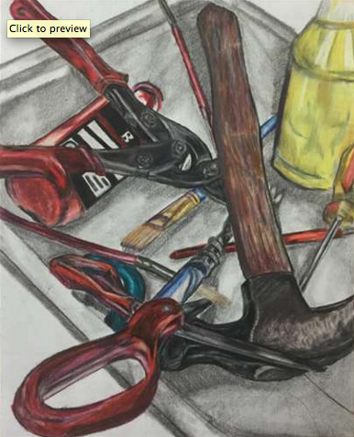
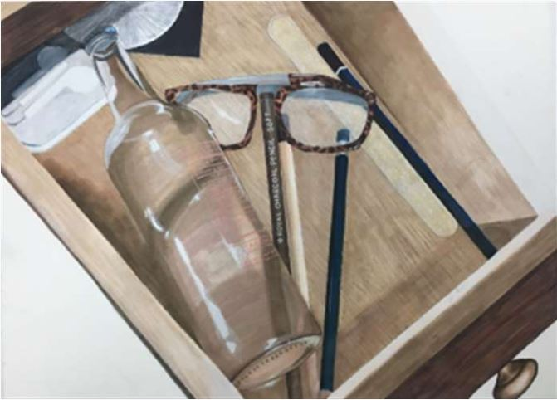
Sketchbook Assignment:
SHAPE
Medium: Choice
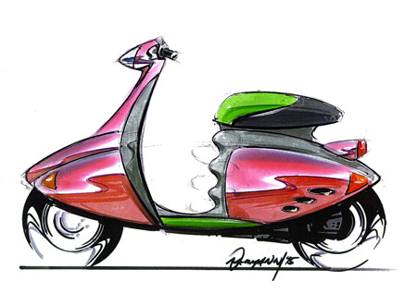
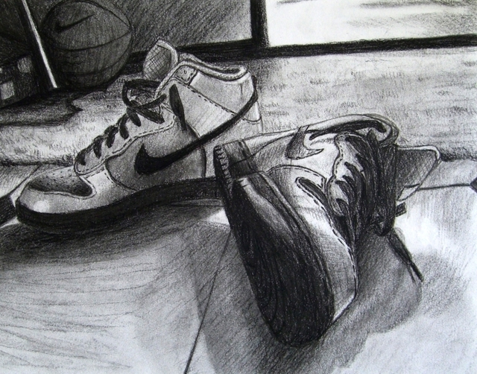
Draw or design any kind of vehicle, or draw a pair of something - a pair of shoes, socks, apples, etc.

Sketchbook Assignment:

COLOR
Draw the inside of an object cut in half or sliced – real or imaginary
Medium: Colored pencils – full value
No Markers!

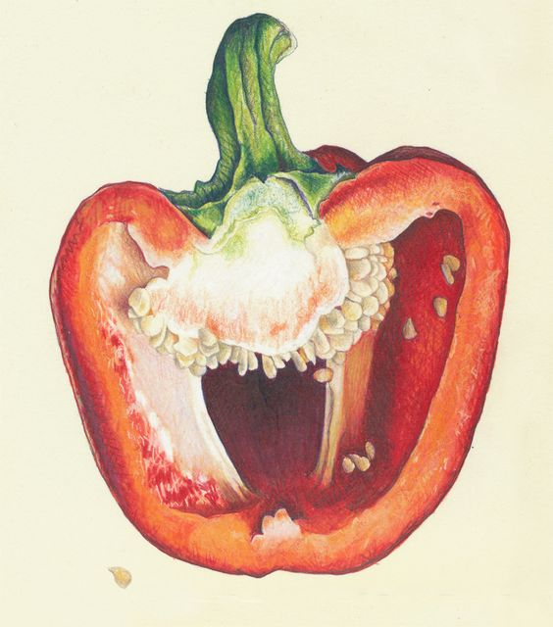
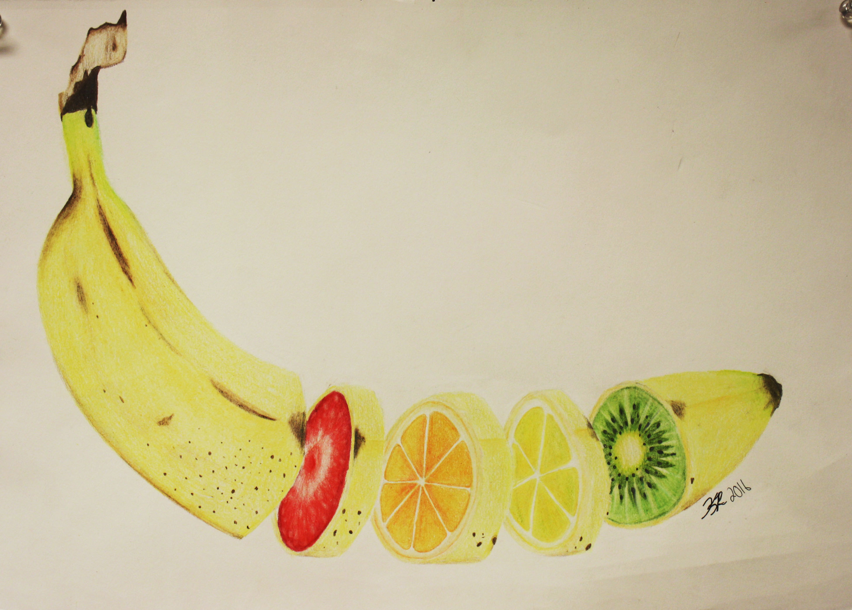

Sketchbook Assignment:

Texture
Medium: 4H – 6B Full Value/shading

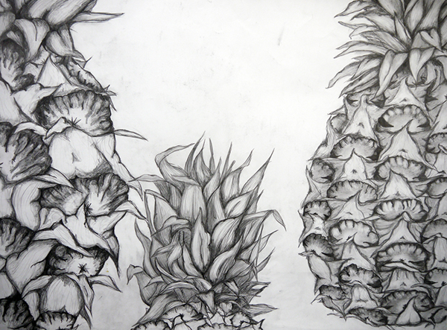

Sketchbook Assignment:

Choice
Show me your skills!

