Name____________________________________ Project __________________________

Elements: Line, Shape, Texture, Form, Color, Space, Value
Principles: Balance, Contrast, Rhythm, Repetition, Pattern, Emphasis, Unity, Variety, Movement
***Use Complete Sentences with proper grammar, punctuation and spelling.
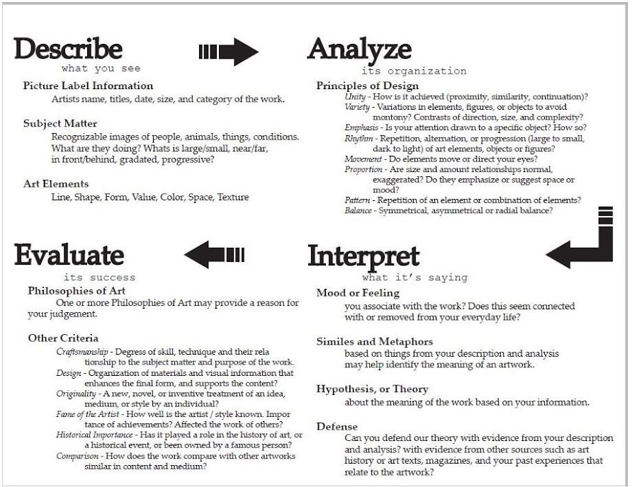

***Use Complete Sentences with proper grammar, punctuation and spelling.
Describe the work: What media was used for your artwork? Describe the content using the appropriate elements:

Student: If you did more than what was expected, circle Mastered. If you met the Expectation or are Progressing towards meeting it, circle it. If a requirement is poor or missing, please mark it as Developing.
 | Mastered | Expected | Progressing | Developing
Analyze  Elements & Principles of Design | The artwork shows that the student applied the required principles of design while using three or more elements effectively. Student exceeded expectations. | The artwork shows that the student applied the required principles of design while using two or more elements effectively. Student met expectations. | Some degree of planning of composition/design. Limited use of effective elements and principles of design. | _______

Interpret  Execution, Originality, & Uniqueness | The artwork was successfully executed from concept to completion. It is unique & original with evidence from references and peers. | The artwork was successfully executed from concept to completion. It is fairly unique & original with some evidence from references or peers. | The artwork was moderately executed from concept to completion. It is somewhat original with slight evidence from references or peers, but could be more unique. | _______

Interpret  Requirements & Depth | All requirements are met, fulfilling the learning targets. Subject and media were explored beyond what was required. Personal connection and point of view is evident. | All requirements are met. Subject and media were explored as required. Some personal connection or point of view is evident. | Most requirements are met. Subject and media were marginally explored. Needs a stronger personal connection or point of view. | _______

Evaluate  Craftsmanship & Neatness | Overall, the project is clean and without major defects. The artwork is outstanding because of the attention to procedures at all stages of completion, including finishing techniques. | Overall, the project is clean and without major defects. With a little more attention to finishing techniques, the artwork could be outstanding. | Satisfactory project is a bit careless. Demonstrates an average understanding of the procedures, but needs attention to finishing techniques. | _______

Evaluate  Time & Management | Class time was used wisely. Additionally, time and commitment went into the planning and design of the artwork outside of class. Fully independently motivated. | Class time was used wisely. Time and commitment went into the planning and design of the artwork. Mostly independently motivated. | Class time was mostly used wisely. Time and commitment went into the planning and design of the artwork. Needed direction throughout the project. | _______

